No. | Answer
In acidic solutions | [H₃O⁺] | > | [OH–]
In basic solutions | [H₃O⁺] | < | 10^{–7} mol L⁻¹
In neutral solutions | [OH–] | = | 10^{–7} mol L⁻¹
In acidic solutions | [H₃O⁺] | > | 10^{–7} mol L⁻¹
In basic solutions | [H₃O⁺] | < | [OH–]
In acidic solutions | [OH–] | < | 10^{–7} mol L⁻¹
In basic solutions | [OH–] | > | 10^{–7} mol L⁻¹

Water undergoes self-ionisation according to the following equation:
H₂O(l) + H₂O(l) ⇌ H₃O⁺(aq) + OH–(aq)
As the mole ratio of H₃O⁺(aq) to OH–(aq) in this equation is 1:1, the molar concentrations of H₃O⁺(aq) and OH–(aq) must remain equal in pure water.
a CO₂(g) + H₂O(l) ⇌ H₂CO₃(aq)
H₂CO₃(aq) + H₂O(l) ⇌ H₃O⁺(aq) + HCO₃–(aq)
b 1000 times (The pH scale is logarithmic, and a change of 1 pH unit equals a 10-fold change in [H₃O⁺].)
a i HNO₃ is a strong, monoprotic acid. It completely ionises in water.
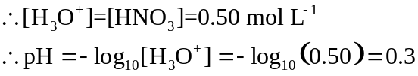
ii Ba(OH)₂ completely dissociates in water to produce 2 OH– ions per unit of Ba(OH)₂.
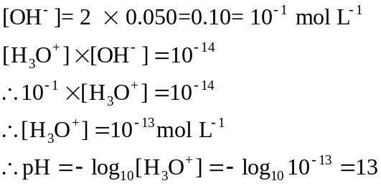
b They could have different acid strengths (e.g. one strong, one weak) or be different acid types (e.g. one monoprotic, one diprotic).
 | K_{w} = [H₃O⁺] [OH⁻]
1.0 g in 1.0 mL, ∴ 1000 g in 1.0 L, ∴ 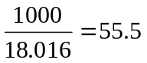 mol in 1.0 L
∴ 56 mol L⁻¹
a As this is an endothermic reaction in the forward direction, an increase in temperature will cause the reaction to proceed forward, thus increasing the concentrations of both H₃O⁺ and OH– ions. Therefore the equilibrium constant, K_{w}, will increase with an increase in temperature.
b As pH is defined in terms of the concentration of H₃O⁺ ions, an increase in temperature results in a higher concentration of H₃O⁺ and so a lower pH value for pure water.
c The concentrations of both H₃O⁺ and OH– will increase to precisely the same extent with an increase in temperature, as can be seen from the stoichiometric 1:1 ratio in the equation. Thus, although both K_{w} and pH change with temperature, the water will remain neutral. (Pure water is always neutral, but it only has a pH of precisely 7 at 25°C.)
a [H₃O⁺] = 10^{–pH} = 10^{–6.7} = 2.0 × 10^{–7} mol L⁻¹
b [OH–] = [H₃O⁺] = 10^{–pH} = 10^{–6.85} = 1.4 × 10^{–7} mol L⁻¹
c K_{w} = [H₃O⁺][OH–] = [H₃O⁺]² = (10^{–pH})² = (10^{–7.1})² = 10^{–14.2} = 6.3 x 10⁻¹⁵

